FILL REGISTRATION INSTRUCTIONS Please review this document or skip to the section that is most relevant to your concerns.

NOTE: The FILL program has two branches – FILL Florham (at Fairleigh Dickinson’s Florham Campus) and FILL Metro (at FDU’s Metropolitan Campus). The following instructions are for FILL Florham.

GENERAL INSTRUCTIONS
The FILL registration process uses an online registration form – a unique Google Doc (document) that Bruce creates for the program and the upcoming semester.
- This single form is the only form you need to register for university classes and/or FILL classes.
- DO NOT attempt to register for the FILL program using any other form or process. Make sure you are using the form for the correct semester and year.
- Please check your email or the FILL website for the precise registration dates. When registration begins, Bruce will email the registration form to fill@fdu.edu and will post it on the home page of the website www.fdu.edu/fill
- FILL registration is divided into Initial Registration (when everyone has the same chance for registering for a class) and General Registration (first come, first served).
- During Initial Registration (Monday – Friday), registrants do not gain any advantage by registering early so long as they complete their registration form during this Initial FILL Registration period
- During Initial Registration, each student and each FILL instructor will be allowed two (but only two) "priority" class selections. If you designate a class as a "priority" class it means you will automatically be registered for that class (assuming there are enough seats) and given priority over any student or instructor who does not use the priority designation for this class.
- During General Registration anyone many register at any time; if there are seats open for a course, they will be admitted to the course.
- General Registration begins after Initial Registration and at the end of FDU’s Drop/Add period which is 2 weeks into the official university start of the semester.
- For both Initial and General Registration FILL students and FILL Instructors (who are teaching for the coming semester) all register at the same time.
- Instructors SHOULD NOT sign up for their own courses; this will take a seat away from a student.

REMINDERS
- Please do not try to register more than once; if you register multiple times, you may be charged twice, introduce errors, delay your registration process, or get locked out of classes; if you need to make a change, please email Bruce (bpeabody@fdu.edu). Again, DO NOT make a change by submitting a second registration form!
- You do NOT need a Gmail address to access the registration document
- You can access the registration document through a tablet, phone, or computer
- Please do not register for classes that have overlapping dates; the FILL program reserves the right to withdraw a student or an instructor from a class if a student or instructor has registered for two classes that overlap, that is, where one or more class session overlaps with another class they have selected. So please pay attention to your schedule and avoid registering for classes that meet at the same time.

FORM INSTRUCTIONS
The registration form is a single sheet/page, but make sure you click "submit" when you are satisfied with your choices and ready to register. In general, please contact Bruce or Theresa (973-443-8750 or tree@fdu.edu) if you see any errors or encounter any problems with the registration process.
- Please make your selections carefully and respectfully – do not sign up for classes you are unlikely to attend and do not sign up for more classes than you can reasonably enjoy.
- Carefully enter your name, email, your ID# (located on the back of your ID card) & other info in the spaces provided; if you aren't sure of something leave it blank and Bruce will fix it; please be especially careful of your email since this is the address we will use to communicate with you
- The registration form will include a numbered, sequential listing of each FILL course. Please note that there may be changes from the initial course listings. You can also find course information on the FILL website (www.fdu.edu/fill) – click on “Classes.”
- Please know what FILL classes (e.g., M03, M07, W02) you want to take,
- For your FILL regular and “Priority” class registrations you will simply fill in the bubble next to the entry which says either "Regular" or “Priority" registration so that it goes from clear to dark/filled in; if a class is closed and you want to be added to the waitlist, click on the circle/bubble next to the “Waitlist” button.
- You always can click "Clear selection" to remove any errors; if you make a mistake or need to change your classes after you click on “submit” please contact Bruce at bpeabody@fdu.edu; DO NOT submit a second registration or your registration may be delayed or denied
- Simply skip over any classes you don't want to register for;
- When you are happy with all your choices, make sure you click "Submit" at the end of the registration form.
- If you are registering for a university course have the following information ready:
  - the course prefix (HIST, GOVT, CJUS, PSYC, LITS, etc.);
  - the course number (4 digits);
  - the course section (usually 2 digits, usually in the 30s or 60s);
  - name of the course;
  - the instructor name.
For example: “HIST 2348 section 31 America in the Age of Reform – Darden”
- If you want to register for more than one university course, provide all the requested information for BOTH courses (but please note you will receive an additional fee if you register for more than one university course).
Again, students who make a class a Priority class will be put to the top of the list for this class (and will be privileged or prioritized before regular registrants). After students have used up their two priority classes, they may still register for additional classes, but they will only be registered if there are remaining seats after all the “Priority” classes have been filled. A student/instructor who tries to register for more than two “Priority” classes will only have their first two “Priorities” honored. If there are more Priority registrants for a class than seats, the Priority students will be randomly selected for the available seats with the remaining students placed on a waiting list.

UNIVERSITY COURSE INFORMATION
All FILL students have the option to audit one university course in addition to taking FILL courses. If you are registering for a University class or classes, we are assuming, via the honor system, that you have gotten permission from the relevant professor to audit the class. Please save your permission and be prepared to produce it if asked.

If you don't have permission please DO NOT register for a university class during Initial Registration. You can register for a university class without permission once the semester starts as long as there are open seats. Contact Bruce if you have questions about this.

AFTER REGISTRATION
After you register you will receive an automatic “receipt” of all the classes you tried to register for immediately. Bruce will then email everyone with a separate email for each class. The email will simply contain confirmation of your individual (successful) course registration. In other words, the subject line will say something like "Congratulations! You have been registered for M18: History of Modern Thought." Registered students will also get an email from the instructor about a week before the first class begins. We will NOT email students who are waitlisted or who did NOT get into a class. If you do not receive an email with your class confirmations by Jan 16, you might want to check your Spam/Junk folders, but you can also contact Bruce or Theresa if you can’t find the information.

Please pay by or before FDU’s Drop/Add period which is 2 weeks into the official university start of the semester.
You can pay electronically (service fee) or send a check (made out to FDU) with your name and FILL on the subject line to:
​John Pasqua, Associate Director of Enrollment Services
Fairleigh Dickinson University
285 Madison Ave (M-MS0-04)
Madison, NJ 07940

You can go to the FILL website and click on "Join/Pay" for more information about registration and payment.

We will provide all FILL instructors with preliminary rosters after Initial Registration; any FILL student who registers after preliminary rosters have been distributed will NOT be on these rosters; these students must contact each of their instructors directly, so they can be added to the rosters. At this time we will also decide whether any classes should be canceled based on low enrollments; our current cutoff is 10 for a single instructor course and 20 for a dual instructor course (and a minimum of 3 sessions).

Also, please remember that we ask all FILL instructors to send a welcome note to students about a week before the first class session(s) - whether you are meeting in-person or online. If you are a student and do not receive this notice, it may mean that you are not on the instructor's roster - so please reach out to the instructor at this time.

SAMPLE REGISTRATION FORM
The registration form will look something like this:

FALL 2025 Registration FORM (FILL Classes & University Audit)
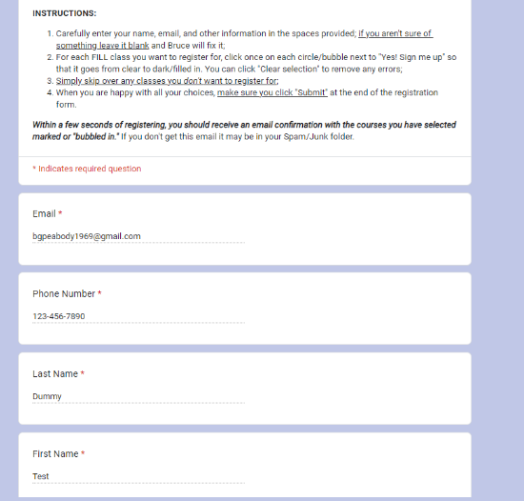
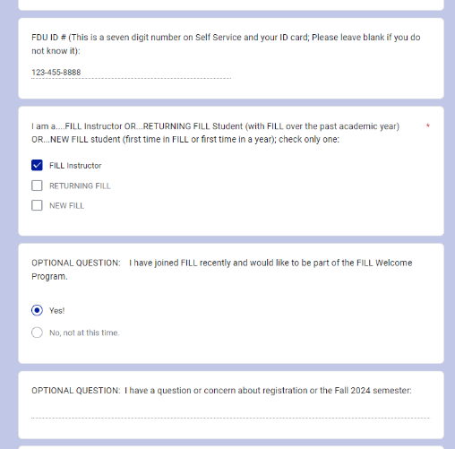
Keep on scrolling through the form; no matter how many courses you register for, you must go to the end of the form to click on the “Submit” button
Do your best to provide an accurate email; we will automatically send your course selections to this email and whatever you type will go on the Instructors rosters

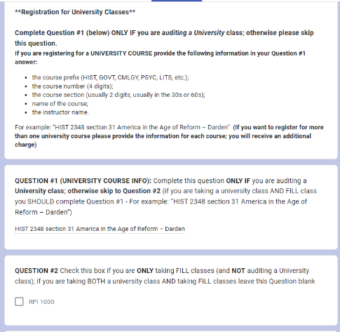
Leave this blank/skip if you are NOT taking a university class or aren’t yet sure
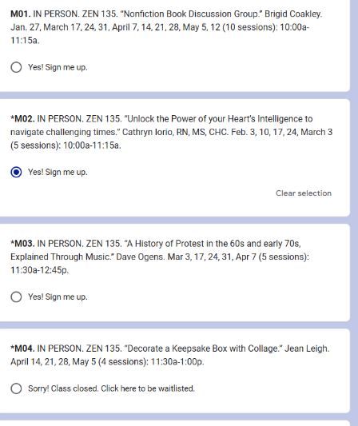

NOTE: New option to select up to two “Priority” classes; Leave blank the selections you DON’T want
O Yes! Make this one of my 2 Priority classes!
O Yes! Sign me up

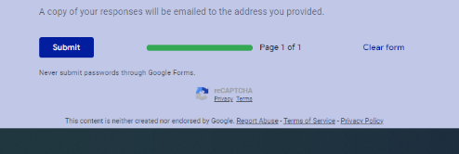
“Bubble” the selections you want
If you make a mistake, you can click on the bubble a second time to undo it or click on “Clear section”
When you are satisfied and ready to register, make sure you click “Submit”
Keep on scrolling through the form; no matter how many courses you register for, you must go to the end of the form to click on the “Submit” button

